Assumptions, intrusive questions, and bi-visibility
LUXE digital article (approx. 650 words)

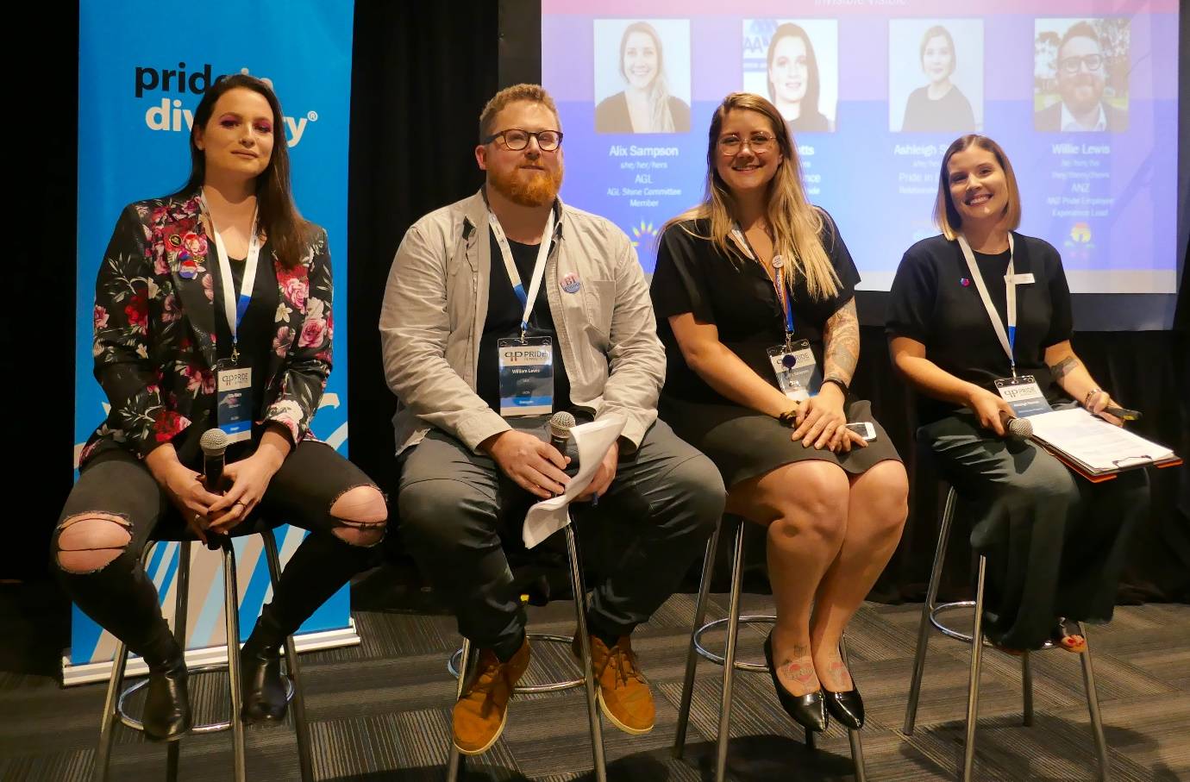
Panel on Bi-visibility in the workplace at 2018 Pride in Practice conference. Ellie Watts (QBE), William Lewis (ANZ Bank), Alix Sampson (AGL), and Ashleigh Sternes (Pride in Diversity).

There has been growing evidence that more support is needed for bisexual people within the Australian workplaces. 2018 saw the release of a number of workplace research studies which have highlighted the perceptions and impacts of being visible, or “out” for bisexual people.
The 2018 Out at Work report produced by RMIT, the Diversity Council of Australia and Star Observer, clearly demonstrated that most LGBTI people are still not entirely out within their workplace, and the importance of visible role models. The study also clearly demonstrated significant gaps in perceptions for bisexual workers, with only 25% of bisexual people feeling being out was important, compared to 57% of lesbian and 46.8% of gay workers. The primary reason given by bisexual people for not being out was that “Colleagues would feel uncomfortable around me”, which was cited by 41% of bisexual participants in the study.
Over the last few years, it has become accepted wisdom within HR departments that an inclusive workplace culture is necessary to allow people to achieve their best, and be most productive. Unfortunately, that accepted wisdom is not yet translating into an inclusive reality for everyone.
The 2018 Australian Workplace Equality Index produced by Pride in Diversity, looked at the issue of whether an LGBTI inclusive culture is actually perceived as being important to LGBTI employees. The results of the study revealed striking differences in the perception of the workplace inclusion programs. When asked how important an LGBTI inclusive workplace culture is, the percentage of intersex people (62%) and bisexual males (65%) viewing it as important was far lower than the results for lesbians (88%) or bisexual females (81%).
A recent panel session at the 2018 Pride in Practice conference in Melbourne delved into issues facing bisexual people in their careers. Panellists included William Lewis from ANZ Bank, Ellie Watts from QBE Insurance, Alix Sampson from AGL, and Ashleigh Sternes from Pride in Diversity.
According to Ellie Watts, she didn’t have a big dramatic personal coming out story with her own family, but acknowledged it was a battle for her to initially figure out her bisexuality. She described the relief she felt when she came out to her parents, and that her parents were quite accepting and relaxed, and a little confused about how emotionally difficult coming out was for her.
While coming out to her family was a relief, it didn’t mean that Watts felt any urgency or need to come out at work. It wasn’t until some years later when she joined QBE, and learnt about QBE’s Pride group on her first day at work, that she started to consider coming out at work. Watts reflected, “For me it was a process over time, testing the water. It was helped by the fact that I have a gay manager.”
One of the key issues raised by the panellists were the frequent intrusive and inappropriate questions they had faced from work colleagues, and they offered some examples, including:
- What percentage Bi are you?
- Have you ever slept with a girl/guy?
- How many threesomes have you had?
- When will you make up your mind?
- Is this something you will grow out of?
Another concern expressed was the lack of bisexual people visible in wider society and pop culture. The observation was made that bisexual characters in film and TV are routinely “erased” as bisexual, and instead described as gay or lesbian, which makes it hard to find role models.
Watts also explained that she felt that being in a relationship placed additional pressures on her decision to come out at work. She outlined how being in a relationship creates more workplace questions, and the need to constantly explain her family situation. “You are always preparing yourself for the stereotypes and the comments that will follow afterwards. It is exhausting to keep educating people.”
People who are looking to be allies to bisexual colleagues should simply accept bisexual identities when they are disclosed, avoid making assumptions, and be mindful of language.

